Cairo University Faculty of Computers and Information



**CS352 – Software Engineering II**

**Phase 3**

**2017**

**Project Team**

|  |  |  |  |
| --- | --- | --- | --- |
| **ID** | **Name** | **Email** | **Mobile** |
| 20140141 | Sameh Mohamed | [Samehlol16@gmail.com](mailto:Samehlol16@gmail.com) | 01147807779 |
| 20140091 | Ehab Mustafa | [E7abmostafa@gmail.com](mailto:E7abmostafa@gmail.com) | 01112700405 |
| 20140067 | Emam Mahmoud | [Emammahmoud95@gamil.com](mailto:Emammahmoud95@gamil.com) | 01141483190 |
| 20140262 | Mariam Ibrahim Shahin | [mariamibrahimshahin@outlook.com](mailto:mariamibrahimshahin@outlook.com) | 01153910691 |
| 20140126 | Roaya Mohsen | [Roaya.mohsen.mohey@gmail.com](mailto:Roaya.mohsen.mohey@gmail.com) | 01149977520 |
|  |  |  |  |

**Staff: Dr Amr Kamel** [a.kamel@fci-cu.edu.eg](mailto:a.kamel@fci-cu.edu.eg)

**Dr Khadija Mohamed** [kelbedweihy@fci-cu.edu.eg](mailto:kelbedweihy@fci-cu.edu.eg)

**TAs:**

**Eng. Regia Mohamed** [r.mohamed@fci-cu.edu.eg](mailto:r.mohamed@fci-cu.edu.eg)

Contents

Your Restful API (In case of you choose SOA ) 2

Class diagram design 17

Used Design patterns 17

Trello workspace screenshot 18

Github repository link 18

# Your Restful API (In case of you choose SOA )

|  |  |
| --- | --- |
| **Service name** | **Login()** |
| **Input type** | **POST** |
| **Service URL** | **localhost:8080/user-login** |
| **Parameters** | |  |  | | --- | --- | | **NAME** | **Description** | | **User** | **It holds the information about the user like Username and Password** | |
| **Example request** | **POST**  **Localhost:8080/ user-login ?username=Mariam&password=123456789** |
| **Example response** | **{1}** |

|  |  |
| --- | --- |
| **Service name** | **StudentSignUp()** |
| **Input type** | **POST** |
| **Service URL** | **localhost:8080/add-student** |
| **Parameters** | |  |  | | --- | --- | | **NAME** | **Description** | | **Student** | **Object from student holds the information** | |
| **Example request** | **Localhost:8080/add-student?name=Mariam Ibrahim&username=Mariam&password=123456&email=mariam@outlook.com&age=32&gender=F** |
| **Example response** | **{true}** |

|  |  |
| --- | --- |
| **Service name** | **TeacherSignUp()** |
| **Input type** | **POST** |
| **Service URL** | **localhost:8080/add-teacher** |
| **Parameters** | |  |  | | --- | --- | | **NAME** | **Description** | | **teacher** | **Object that holds the information about the teacher.** | |
| **Example request** | **Localhost:8080/add-teacher?name=Mariam** [Ibrahim&username=Mariam&password=123456&email=mariam@outlook.com&age=32&gender=F](mailto:Ibrahim&username=Mariam&password=123456&email=mariam@outlook.com&age=32&gender=F) |
| **Example response** | **{false}** |

|  |  |
| --- | --- |
| **Service name** | **Show Courses** |
| **Input type** | **GET** |
| **Service URL** | **Localhost:8080/show-courses/{categoryName}** |
| **Parameters** | |  |  | | --- | --- | | **NAME** | **Description** | | **categoryName** | **Provide Category name for Select** | |
| **Example request** | **Localhost:8080/show-courses/Math** |
| **Example response** | [{"courseName":"Math2","description":"Let's Solve Some math equation form all Degre","id":24,"minimunAge":14},{"courseName":"math","description":"Create Exist Course Must not Create","id":25,"minimunAge":4},{"courseName":"Java","description":"asfjasjvfj","id":26,"minimunAge":3}] |

|  |  |
| --- | --- |
| **Service name** | PlayGame |
| **Input type** | **GET** |
| **Service URL** | **localhost:8080/playgame/Gameid** |
| **Parameters** | |  |  | | --- | --- | | **NAME** | **Description** | | **GameId** | **The id of the game which student or teacher want to play** | |
| **Example request** | **localhost:8080/playgame/Gameid=6** |
| **Example response** | [{"answers":[{"answerId":23,"correctAnswer":false,"answer":"20"},{"answerId":22,"correctAnswer":true,"answer":"15"},{"answerId":21,"correctAnswer":false,"answer":"10"},{"answerId":20,"correctAnswer":false,"answer":"5"}],"level":2,"question":"20-5=?","questionId":8},{"answers":[{"answerId":19,"correctAnswer":false,"answer":"3"},{"answerId":16,"correctAnswer":true,"answer":"5"},{"answerId":18,"correctAnswer":false,"answer":"2"},{"answerId":17,"correctAnswer":false,"answer":"10"}],"level":1,"question":"2+3=?","questionId":6}] |

|  |  |
| --- | --- |
| **Service name** | getQuestion |
| **Input type** | **GET** |
| **Service URL** | localhost:8080/playgame/{gameID}/{questionIndex} |
| **Parameters** | |  |  | | --- | --- | | **NAME** | **Description** | | gameID | **The id of the game which student or teacher want to play** | | questionIndex | **The index of the question in the game to show** | |
| **Example request** | **localhost:8080/playgame/Gameid=6&** questionIndex=2 |
| **Example response** | {"answers":[{"answerId":19,"correctAnswer":false,"answer":"3"},  {"answerId":16,"correctAnswer":true,"answer":"5"},{"answerId":18,  "correctAnswer":false,"answer":"2"},{"answerId":17,"correctAnswer"  :false,"answer":"10"}],"level":1,"question":"2+3=?","questionId":6} |

|  |  |
| --- | --- |
| **Service name** | SaveGame |
| **Input type** | **GET** |
| **Service URL** | localHost:8080/SaveStudentGame/{GameID}/{Username} |
| **Parameters** | |  |  | | --- | --- | | **NAME** | **Description** | | GameID | **The id of the game which student or teacher want to play** | | Username | **The user Id to save Game data to this student** | |
| **Example request** | localhost:8080/SaveStudentGame/GameID=6/Username=emam_Mahmoud |
| **Example response** | **{true}**  **{false}** |

|  |  |
| --- | --- |
| **Service name** | **Add Course** |
| **Input type** | **POST** |
| **Service URL** | **http://localhost:8080/addcourse/{categoryName}/{username}** |
| **Parameters** | |  |  | | --- | --- | | **NAME** | **Description** | | **Username** | **Provide Teacher Username** | | **Category Name** | **Provide Category Name** | | **Course** | **Provide Course Data To Add** | |
| **Example request** | [http://localhost:8080/addcourse/Math/sameh?CourseName=”Math”&MinimumAge=10&description=”MathisveryEasy](http://localhost:8080/addcourse/Math/sameh?CourseName=)**”** |
| **Example response** | **{true}** |

|  |  |
| --- | --- |
| **Service name** | **Show Course Games** |
| **Input type** | **GET or POST** |
| **Service URL** | **http://localhost:8080/GameInCourse/show-Course-games/{courseName}** |
| **Parameters** | |  |  | | --- | --- | | **NAME** | **Description** | | **CourseName** | **Provide CourseName to Get Game in it** | |
| **Example request** | <http://localhost:8080/GameInCourse/show-Course-games/Math> |
| **Example response** | [{"questions":[{"answers":[{"answerId":37,"answer":"25","correctAnswer":true},{"answerId":38,"answer":"10","correctAnswer":false},{"answerId":39,"answer":"50","correctAnswer":false},{"answerId":40,"answer":"20","correctAnswer":false}],"level":1,"question":"5*5=?","questionId":10}],"description":"afsnmfklasbfbk","gameId":6,"gameName":"sara","numOfLevels":2},{"questions":[{"answers":[{"answerId":33,"answer":"25","correctAnswer":false},{"answerId":36,"answer":"0","correctAnswer":false},{"answerId":34,"answer":"20","correctAnswer":false},{"answerId":35,"answer":"10","correctAnswer":true}],"level":2,"question":"5+5=?","questionId":9},{"answers":[{"answerId":31,"answer":"3","correctAnswer":true},{"answerId":30,"answer":"2","correctAnswer":false},{"answerId":29,"answer":"0","correctAnswer":false},{"answerId":32,"answer":"1","correctAnswer":false}],"level":1,"question":"1+2=?","questionId":8}],"description":"just try to play","gameId":5,"gameName":"start with math","numOfLevels":2}] |

|  |  |
| --- | --- |
| **Service name** | Get Teacher Courses in Category |
| **Input type** | **GET** |
| **Service URL** | **http://localhost:8080/get-courses/{CategoryName}/{username}** |
| **Parameters** | |  |  | | --- | --- | | **NAME** | **Description** | | **Username** | **Provide Teacher Username** | | **CategoryName** | **Provide Category Name** | |
| **Example request** | <http://localhost:8080/get-courses/Math/sameh> |
| **Example response** | [{"courseName":"Math2","description":"Let's Solve Some math equation form all Degre","id":24,"minimunAge":14},{"courseName":"math","description":"Create Exist Course Must not Create","id":25,"minimunAge":4},{"courseName":"Java","description":"asfjasjvfj","id":26,"minimunAge":3}] |

|  |  |
| --- | --- |
| **Service name** | Get Student Courses |
| **Input type** | **GET** |
| **Service URL** | **http://localhost:8080/get-Student-courses/{usename}** |
| **Parameters** | |  |  | | --- | --- | | **NAME** | **Description** | | **Username** | **Provide Student Username** | |
| **Example request** | **http://localhost:8080/get-Student-courses/sameh2** |
| **Example response** | **[{}]** |

|  |  |
| --- | --- |
| **Service name** | **Get Teacher Courses** |
| **Input type** | **GET** |
| **Service URL** | **http://localhost:8080/get-Teacher-courses/{username}** |
| **Parameters** | |  |  | | --- | --- | | **NAME** | **Description** | | **Username** | **Provide Teacher username** | |
| **Example request** | <http://localhost:8080/get-Teacher-courses/sameh> |
| **Example response** | [{"courseName":"Math2","description":"Let's Solve Some math equation form all Degre","id":24,"minimunAge":14},{"courseName":"Java","description":"asfjasjvfj","id":26,"minimunAge":3},{"courseName":"math","description":"Create Exist Course Must not Create","id":25,"minimunAge":4}] |

|  |  |
| --- | --- |
| **Service name** | **Register Student in Course** |
| **Input type** | **Post** |
| **Service URL** | **http://localhost:8080/student/add-course/{username}/{courseName}** |
| **Parameters** | |  |  | | --- | --- | | **NAME** | **Description** | | **Course Name** | **Provide Course Name** | | **Username** | **Provide Student Username** | |
| **Example request** | **http://localhost:8080/student/add-course/sameh2/Math** |
| **Example response** | **[{true}]** |

|  |  |
| --- | --- |
| **Service name** | **Create Game** |
| **Input type** | **Post** |
| **Service URL** | **http://localhost:8080/game/create-game/{courseID}/{typeID}/{username}** |
| **Parameters** | |  |  | | --- | --- | | **Name** | **Description** | | **CourseID** | **The id of the course that will be selected** | | **TypeID** | **The id of the type that will be selected** | | **Username** | **The username of the teacher** | |
| **Example request** | **http://localhost:8080/game/create-course/1/1/ehab** |
| **Example response** | **[{1}]** |

|  |  |
| --- | --- |
| **Service name** | **Create Question** |
| **Input type** | **Post** |
| **Service URL** | **http://localhost:8080/create-question/{GameID}** |
| **Parameters** | |  |  | | --- | --- | | **GameID** | **The id of the game that the question will be added in it.** | |
| **Example request** | **http://localhost:8080/game/create-question/1** |
| **Example response** | **[{1}]** |

|  |  |
| --- | --- |
| **Service name** | **Create Answer** |
| **Input type** | **Post** |
| **Service URL** | **http://localhost:8080/create-answer/{QID}** |
| **Parameters** | |  |  | | --- | --- | | **QuestionID** | **The id of the question that the answer will be added in it.** | |
| **Example request** | **http://localhost:8080/game/create-answer/1** |
| **Example response** | **Will add the answer to the question** |

|  |  |
| --- | --- |
| **Service name** | **Get types** |
| **Input type** | **Get** |
| **Service URL** | **http://localhost:8080/game/get-type** |
| **Parameters** |  |
| **Example request** | **http://localhost:8080/game/get-type** |
| **Example response** | [{"typeId":2,"typeName":"MCQ"},{"typeId":1,"typeName":"TrueFalse"}] |

|  |  |
| --- | --- |
| **Service name** | **Get Category** |
| **Input type** | **Get** |
| **Service URL** | **http://localhost:8080/get-category** |
| **Parameters** |  |
| **Example request** | **http://localhost:8080/get-category** |
| **Example response** | [{"categoryName":"Math","courses":[{"courseName":"Math1","description":"Hello Math1","id":1,"minimunAge":22},{"courseName":"Math2","description":"hello world","id":2,"minimunAge":30}],"categoryId":1},{"categoryName":"Science","courses":[],"categoryId":2}] |

# Class diagram design

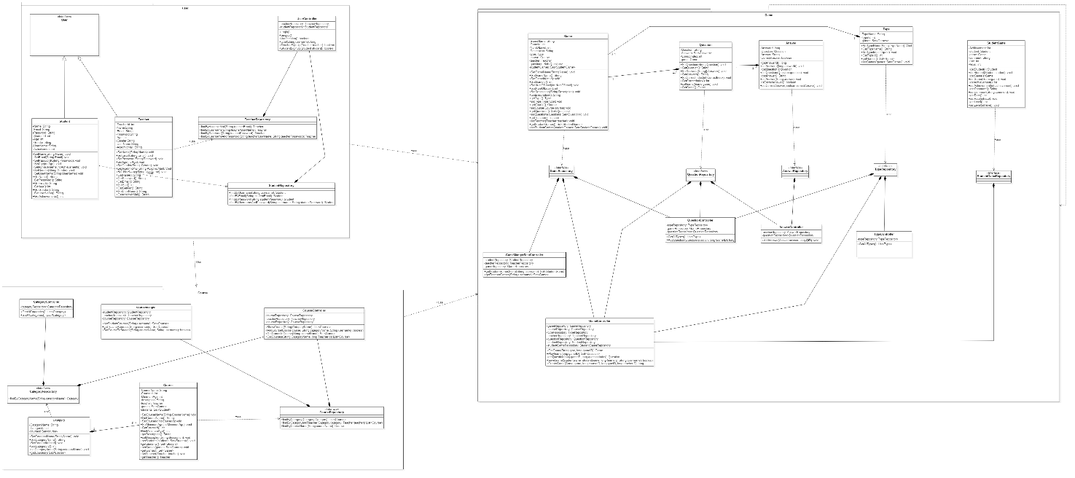

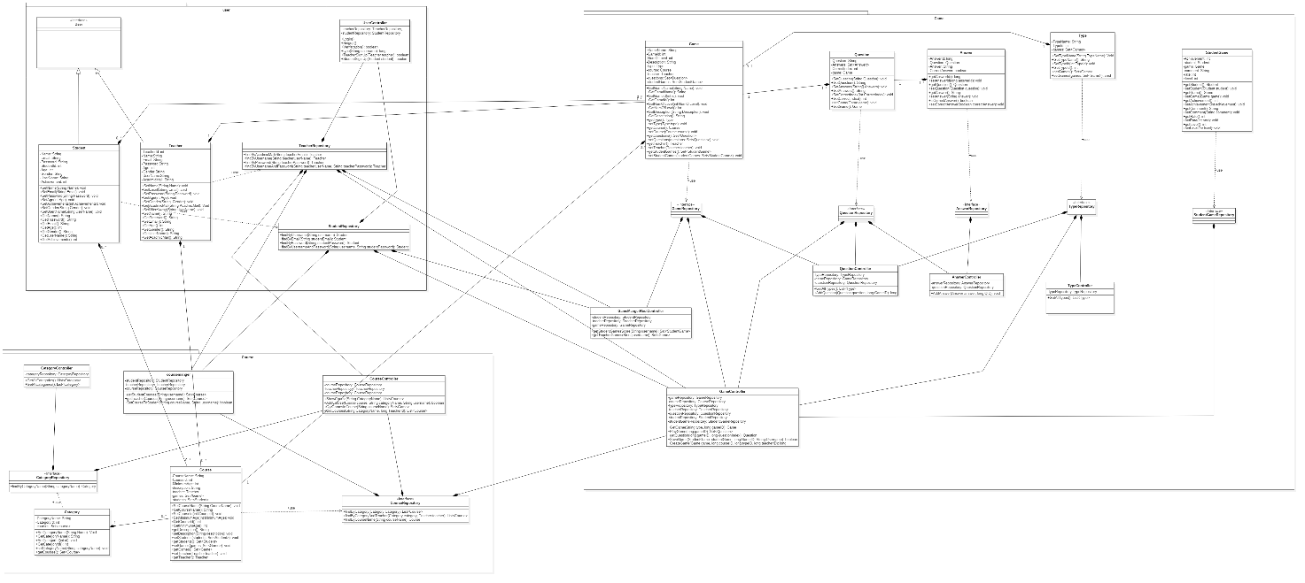

# Used Design patterns

List any design patterns you used and briefly explain the reason behind using this design pattern.

# Trello workspace screenshot

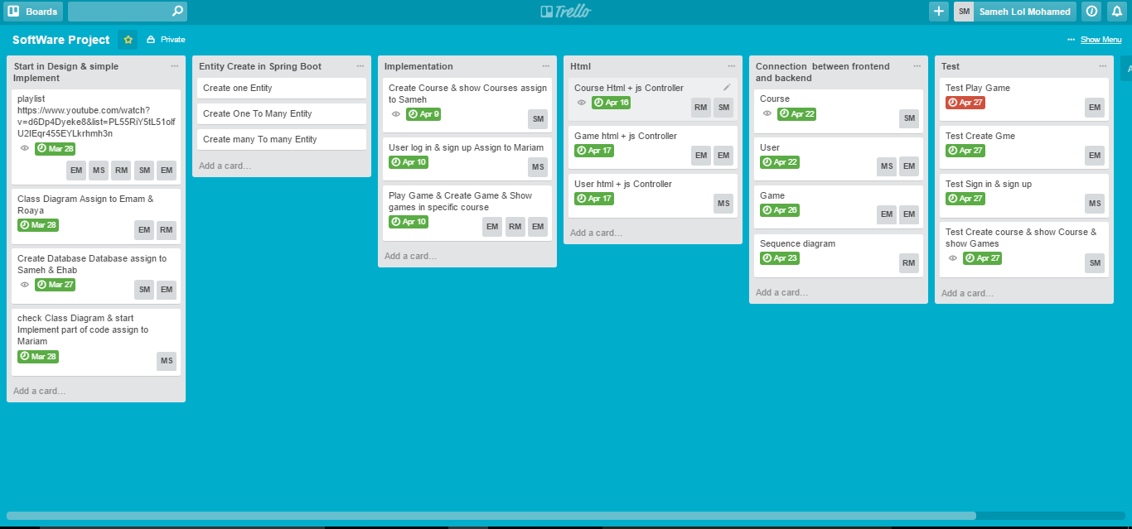

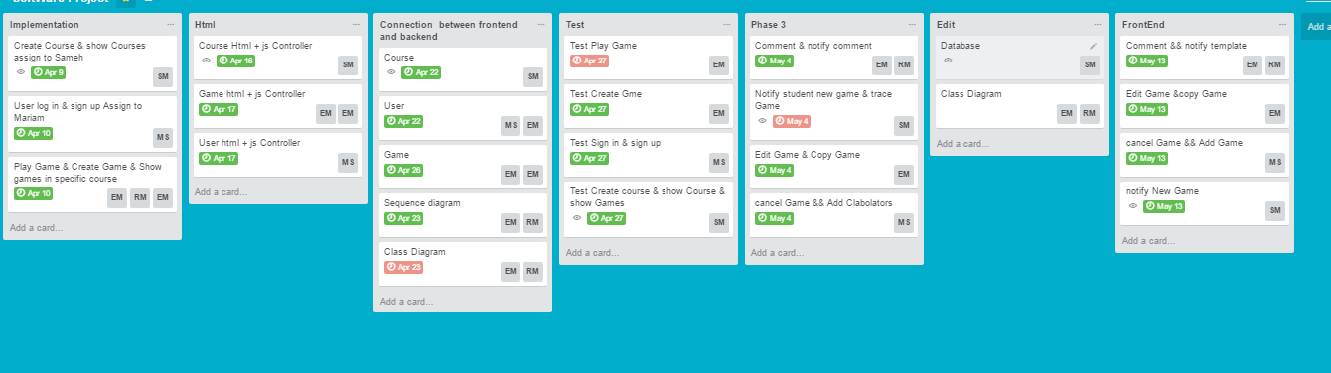

# Github repository link

<https://github.com/Sameh16/SoftwareProject.git>